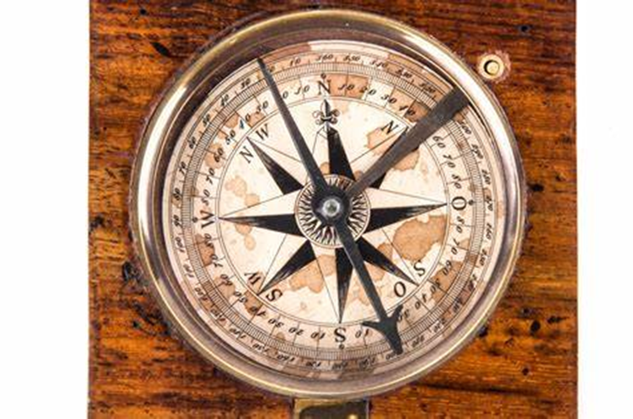

Words "Magnetic Compass"

1800s sextant navigation tool


Words "sextant"